Лабораторной работе №1

Проверка ссылок

Студент: Давтян Ашот

Группа 21ИС-20

**1.Количество битых ссылок и результат**

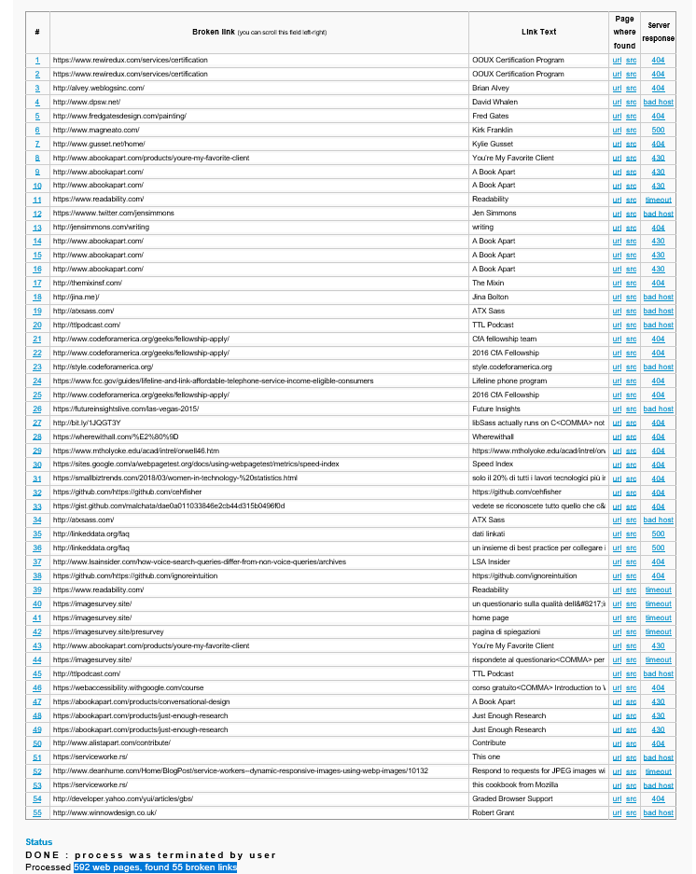

**Результат:**

592 web pages, found 55 broken links

**2.Укажите URL с ошибкой 500 и скриншот**

URL

1. <http://www.gusset.net/home/>

2. <http://linkeddata.org/faq>

3. <http://linkeddata.org/faq>





**3. Укажите URL с ошибкой 404**

URL

1. <https://alistapart.com/about/masthead/>

2. <https://alistapart.com/article/how-to-sell-ux-research/>

3. <https://alistapart.com/author/sophiavoychehovski/>

4. <https://alistapart.com/about/masthead/>

5. <https://alistapart.com/about/masthead/>

6. <https://alistapart.com/about/masthead/>

7. <https://alistapart.com/about/masthead/>

8. <https://alistapart.com/event/responsive-style-guides/>

9. <https://alistapart.com/author/cydharrell/>

10. <https://alistapart.com/event/responsive-style-guides/>

11. <https://alistapart.com/event/responsive-style-guides/>

12. <https://alistapart.com/event/sass-talk/>

13. <https://alistapart.com/event/designing-for-performance/>

14. <https://alistapart.com/article/writing-is-thinking/>

15. <https://alistapart.com/it/article/andiamo-al-cuore-della-accessibilita-digitale/>